Chestnut Hill Elementary
Kindergarten Back-To-School Supplies

**Please be sure to LABEL each of these items with your child’s name**

In school:
- Large Backpack
- Sneakers for the playground and gym
- 2 folders
- 2 packs of 24 count crayons
- 2 packs of glue sticks
- 2 dry erase markers
- Scissors
- T-Shirt for art smock
- Extra set of clothes in a bag
- 2 pairs of headphones (please no earbuds)
- Mask (to be worn everyday if required)
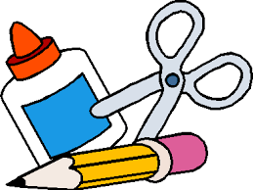
- Water bottle, labeled with students name. Tops that lock work best! (water fountains will not be available)
- Zip lock bags (quart and/ or gallon size)
- package of baby wipes/wet ones

